PROTECTION AND PERMANENCY INFORMATION MEMORANDUM, 15-09

TO: Service Region Administrators
Service Region Administrator Associates
Service Region Clinical Associates
Regional Program Specialists
Family Services Office Supervisors

FROM: Tina Webb, Assistant Director
Division of Protection and Permanency

DATE: December 14, 2015

SUBJECT: New TWIST Screens-Case Planning

The purpose of this memorandum is to provide additional information regarding the new case planning screens in iTWIST. Since training was released, several questions have been received by central office staff and this memorandum services to clarify some of the major points related to this most recent TWIST migration.

Please Note: No requirements regarding case planning timeframes have changed. Only the data entry method has been revised.

- Case plan migration: All case plans created after 2007 will be listed on the “Summary of Case Plans” screen after the migration. Whatever stage these case plans were in at the time of the migration is how they are reflected in the “Current Status” column of this screen. Staff will not be able to edit any case plans that are migrated from cTWIST; they will only be able to be viewed.

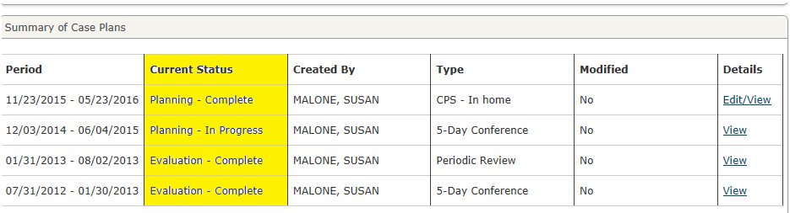

- Case plan evaluation: If a case plan was created and approved in cTWIST, when it is time to evaluate it, staff will need to complete the appropriate case plan evaluation template (listed on the Forms browser) and copy and paste this information into “Contacts.” Staff will then need to create a new case plan, by following the instructions listed in the web based trainings for in-home and out of home case planning:
  - Case Planning Navigation: In-Home; and
  - Case Planning Navigation: OOHC.
Staff can choose to reenter an existing case plan after the iTWIST migration. This will allow them complete the case plan evaluation, when it is due, using the new iTWIST screens. This will not skew the timing of the case plan completion because it is possible to insert in the original date of creation in iTWIST by inserting the true conference date in the “Date of Case Plan Conference” field on the “Case Plan Information” screen.

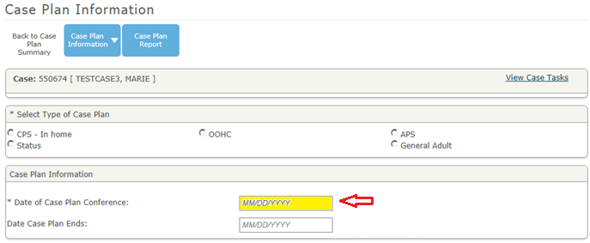

- Linking an assessment to the case plan: On the “FLO/ILO Objectives and Tasks” screen, staff will be able to link new case plans to the investigative assessment that opened the case. It is imperative that staff choose the correct assessment when completing this step; otherwise, the correct objectives will not populate. Once the correct assessment has been chosen, the case plan will always be linked to it.
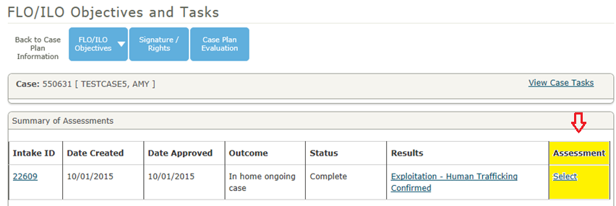

- Case plan deletion: Staff can delete a case plan if it has not been approved by the FSOS. This can be done by choosing “Edit/View” on the “Summary of Case Plans” screen, then checking the following box and clicking “Save”:
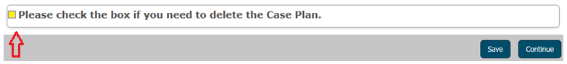

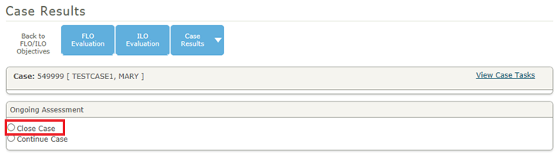
- Close case option: Choosing “Close Case” on the “Case Results” screen does not result in case closure in iTWIST. The SSW will still have to complete all other tasks associate with case closure prior to the case being closed.

- Status offender case plan: If the “Status” case plan is chosen, on the “Case Plan Information” screen, it is important to remember that this will generate an in-home services case plan. If the status child is placed in out of home care, the “OOHC” case plan will need to be selected.
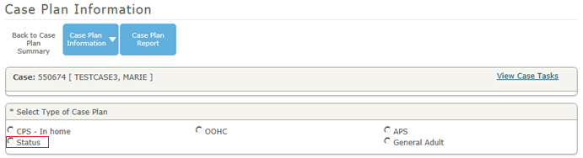

- Permanency goals: When choosing a permanency goal for a child on the “Permanency/Attachment” screen, please note that staff will not be permitted to select the goals of “Emancipation” or “Planned Permanent Living Arrangement” for a child unless that child is at least sixteen (16) years of age.
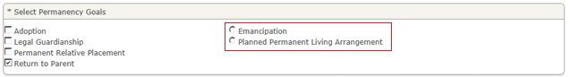

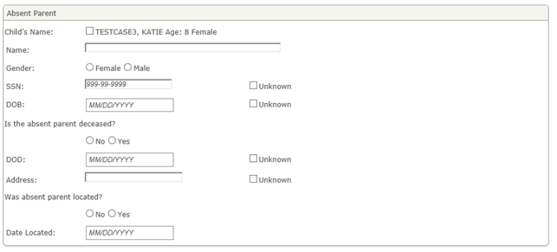
- Absent parent search: When completing the absent parent screens, please note that adding an absent parent to the “Summary of Absent Parents” screen does NOT add them as an individual in the case.

If an absent parent needs to be added as an individual, staff must add them into the “Case Individuals” screen:

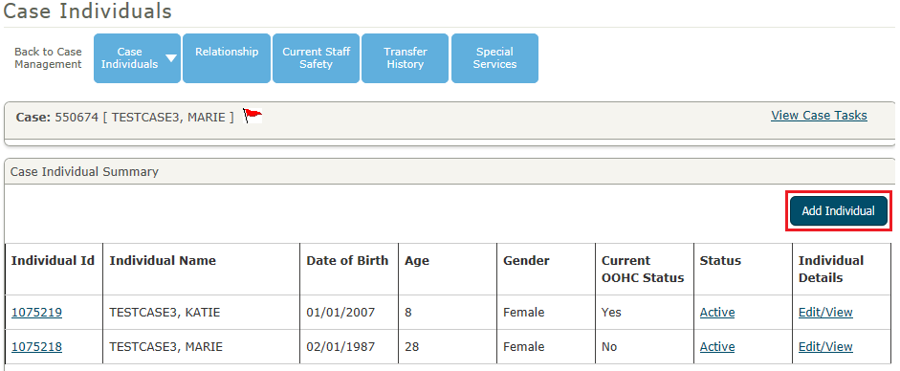

For technical assistance regarding the new iTWIST screens, please contact the TWIST help desk at (502) 564-0104, and choose option 3.

If you have any questions regarding the new in-home case planning process, please contact:
Lucie Estill, Child Protection Branch Manager
Lucie.estill@ky.gov
(502) 564-2136, ext. 3568

If you have questions regarding the out of home care case planning process, please contact:
Tina Hagenbuch, Out of Home Care Branch Manager
Tina.hagenbuch@ky.gov
(502) 564-6852, ext. 3577

